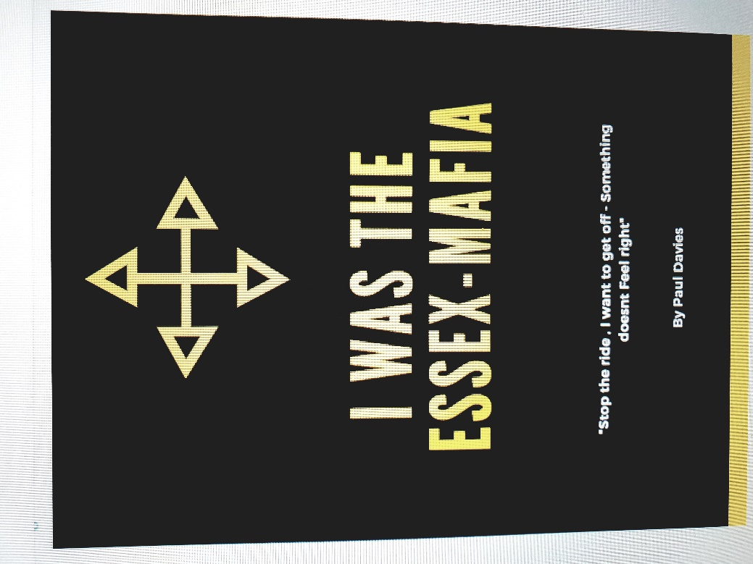

Book: - I was the Essex Mafia

Chapter one :

Loved like a king, But chose the role of a Jester .

Waking up today, was waking up the same yesterday, and will no doubt be the same for tomorrow.

My childhood in one brief sentence was, absolutely outstanding and to this very day my mum and dad are my best of friends.

This was fine for me over the years. fully focused on blagging my way through life and most certainly not taking it seriously , the biggest of issues never really concerning me , I remember at the age of 19 when my son was born I spoke with my wife to be, and said that a few fellas were heading to Glastonbury Festival , my closest person I knew was my sister’s boyfriend , so on the day the van pulled up and 6 of us jumped in ready for the 7 hour drive down to druid town , with not an entrance ticket between us .

In my opinion an experience whilst in the company of these chaps started a chain of events in my life, I believe happened on route about 50 miles from away from our demon weekend, a blue VW Golf in front of us started playing games and "brake - checking us”, nothing out of order , certainly not worthy as to what was about to happen.......

Bearing in mind I was 18 , and these fellas were about 22-30 and big lads , and nasty lads it would come to experience , the next I hear in the back of the van was banging, in an effort to alert us to get out, the crazy little fucker Dan opened the back doors in traffic we jumped out, and see Scott and the others dragging these lads out , they were outnumbered and most certainly not ready for what they were going through as I watched , they got smashed , in a way that was unacceptable , the words themselves I remember, but hearing a man say to another , "one more fucking word cunt and I will fucking rape you" , just reverberated in a way that it is just unforgivable. anyway, I will answer my feelings later on this and other subjects towards the end if this okay as its it now forms my belief system, I think.

upon arrival and 2 hours attempting to get in to the Eves Farm, we looked at the new fencing installation that snugly fitted around the entire festival area, I mean it is massive . undeterred we found 3 lengths of security rail , laid them in a ladder formation and ran up , crossed our fingers , and jumped over , this was a great idea for all of us , except Dan who jumped crossed his fingers and snapped his ankle , he stayed for a full day in pain he possibly did not feel , as the Mitsubishi turbo Ecstasy tablets he was taking stuck him on another planet.

I remember watching Roger Waters singing wish you were here , looking back at over 100 thousand people , ranging from cuddled up, to staring into space, and most chewing the chops off from MDMA or E's , I was fairly sober , but remember the energy that was produced during this moment , this again may have something associated to my later experience. it was powerful, and unforgettable in a way that seems stamped into my soul.

Now I have never ever written anything down , but this is now me , maybe an outlet due to my stressful job , maybe because of events that happened later in life I do not know , and I am now quite sure even if I care , as I feel at peace , the next phase of events again I am unable to really get you ready for , as I do not know what I am going to write , I am sitting here at the moment in my living room with my daughter whilst she watches the Kardashians , deeply plugged into the TV.

I came back from that trip , knowing all about drugs, some that would eventually stick me in rehab , but again this short biography isn't about like some other books that tare the arse out of every single element of an experience , but in short I did 70% of all street drugs , thought I was a plastic gangster , and thought that this was how I was going to conduct myself , a nice guy, "but don't fuck with him to much" , it was safe , I am sure that other blokes will relate to this, I think it’s a protective barrier to prevent physical violence, if you can just be that confident that hopefully this will deter any "geezers" from fucking you up.

as I write this aged 39, I now know this is pathetically incorrect , but did not deter me from joining a football hooligan element…

Chapter Two: -

" Trying to be a chap, but didn’t fancy the slap "

I mentioned earlier that mum and dad gave me everything, not just me, my sister, we grew up the richest of kids, wealthy beyond belief, if love was the currency. we had a couple of holidays a year, 2 cars typical 2.4 family I suppose, although I could write a war and peace novel on just how much I love these two, but I won’t there is no need, as they know.

The reason I mention this as I developed a large cocaine habit, my marriage ended shortly after, after getting married at Circus Circus In Las Vegas several years previously, but I needed help, I went to one DD meeting, flipped my wallet over see a picture of my legend of a son , and never went back, I stayed clean for over 12 years .

Mum and dad were proud of me, to be fair I could have chinned a unicorn and mum would have still said something like " don't worry darling the unicorn probably deserved it" , but as they knew my love for West Ham United , they lovingly brought me a season ticket to the 2006/2007 season , the seat was in the West Stand Lower , seat 214, I went on my own, week in week out. but for all of my bad points I have this natural ability and confidence that I would always then form a group, as I love meeting people, and bringing people together, the fact it was on my terms just made the process a whole lot easier. before the game I would drink in the Queens Public House, it was a ritual, a few beers before the game, talk total shit, head the 3 minute walk up Green Street and into the my Church I called Upton Park.

A particular game that started another event, was away at Wigan, I do not wish for this short book to be about proper Naaaaawty geezers, but this next event started an escalation that was just far too easy . we lost 1- 0 against Wigan , and as I came around the corner 3 Wigan lads had set upon a west ham supporter, now it’s important to note, I can’t fight, or do the crane kick that ended that bloke out of Karate Kid , or do the one inch punch, but I can sound like a guy you may not wisely choose to kick off with , it’s a confidence thing , as if someone did take me on, I would be in a tad of a pickle I jumped in and , and what in my head played out like I was in a scene from Bruce Lees Enter the Dragon, in reality it was a tubby guy, waving his arms around like a hand fan. and this was spotted, I then, in short started drinking with these fellas, moved up the ranks, and became more noticed, which I think is a fair assumption.

I mention the above event as with all parts of my first and last short book, this all leads to the end chapter.
there were plenty of stunning and stupid stories, but as always I go to the last event, the event that led to the next event, and that was West ham Vs Millwall F.C 2007/2008 season in the championship. I have always said that the "top boy" of any hooligan affiliation and his foot soldiers should be snapped up by our military as the precision that they plan their fun, is nothing short of admirable, we were near the middle of the tube , around 85 strong I would imagine, and we then hear the usual "stand" stand" bellowing from the top lads, as the train slowed I noticed the platform looked like a scene from Next on sale day , there must have been 50-80 Millwall F.C firm aptly named " the treatment" , wearing surgical masks , and hypnotic glistening scalpels, basically really scary looking hurty stuff! the echo of "stand" "stand" rang out, and what did the Essex Mafia do, well in fact I remember what I said ........ "Fuck this I’m off"!! . and so, I never associated myself again

So, a quiet life remains?

Not on my watch seemingly.......

Chapter 3 : -

"The Monaco Mafia"

Me and my stunning lady were on a well-deserved break back from Monaco, Danielle had somehow, and I genuinely mean this , she managed to score tickets to this really nice hotel that was on circuit , and literally in the middle of the harbour that was engulfed in wealth of the highest order . if you don't mind there are a couple of stories that I want to write down on the blankness that's currently in front of this sentence,

Danielle and I around 13:00Hrs were sat outside opposite The Casino Di Paris, I remembered it from when Daniel Craig absolutely swaggered out of there and onto the marble cream steps below, just looking far too sharp for his own good, we were sat in the Stunning Cafe Di Paris , just chilling , and watching Bugatti Veron, After Rolls Royce turn left around the roundabout , and watching 25 year old chaps sitting in the driver’s seat , dripping in money , pass by , it made me, feel well ? what’s the opposite to a happy & Hench ?

we noticed a guy, who looked like the don, purple suit, in fact whilst writing this he looked exactly like Reuben Tishkoff, from the Oceans Elevens films, he sees me and Danielle having a laugh and not really being quiet and clearly tourists but gave us a nod of approval. that night we returned , to an annual event simply called "The Billionaires Ball" , now Danielle could make a £3.85 dress from Asda , look like a one off item from Gucci , as she is simply stunning , me on the other hand was clearly draped in the latest seasons lines from Primark, the marble cream steps awaited us , almost had you believing like you was instantly rich the moment you set foot ready to rise to the Grand Oak Door Entrance, do we turn left and try blagging our way in, or head right into the Casino with our 170 Euros .

……………. we turned left without even discussing it,

And walked to the concierge desk who guarded the door , and politely demanded that he show us to our seats, behind the black silk curtain...... there were no allocated seats, all he had to do was ask me any question and I would have melted in front of his eyes, but he didn't, he efficiently swayed the curtain to one side , and then Bonnie and Clyde walked in like they owned the joint, into - the Billionaires Ball, worth a combined total of around £789.56 . I walked to the bar and asked for 2 glasses of LPR Champagne, and arrogantly swiping a 50 Euro Note, leaving the 20 Euro note to keep warm in the wallet. I expected a few notes as change, what I did receive was some devastating news, the fella behind the bar needing further , well several more notes from me, and subsequently leaving us just , well fuck all really for the casino , our financial situation was more suited to the 2p machines at Southend on sea...

Undeterred and with a face like a pro poker player , but crying like a child inside, I scanned the room for where Danielle was sitting, she honestly hand on heart looked knockout, she fitted into place with the other stunning billionaires ladies like a jigsaw puzzle , for me it was now a game of “where’s wally” , although the only wally was me for spunking our nights money for some fizzy blue nun. I took the seat next to Danielle and offered her a small bowl of nuts that I got free whilst being financial bent over, and staring back at us was Mr Ocean’s Eleven surrounded my Thai woman, he looked over and again acknowledging us , and it was at that point I wanted to be his new best mate. About an hour later and before I made a scene and dropped to one knee for him, we left for the Casino with around 30 Euros worth of change in our pocket, and entered sounding like a set of jangling shackled inmates.

Chapter Four:

Money = Power – Happiness = Loneliness

The immaculate Baize circle oval Table we stood at was unreal, in fact the whole evenings visual explosion of beauty was not appreciated until after the event, which is sometimes the case I think you will agree, we “lumped” on 30 euros on Blackjack , and beat the dealer with a cheeky 16 , to his Bust. Me and Danielle went mental , and at one point I am sure I did a Mick Jagger Peacock move, I didn’t have time to hate myself for it though, as we were bringing the house to its knees as we won a further 400 Euros over a few hands, I noticed the other 2 players who joined , they came across as ice cold, Russians , the fella was a unit , and his younger lady he was with was had the most hypnotic eyes I recall , he passed over 6 chips to her from his stack , his stack, for the record, looking a like record breaking Jenga tower.
The chips were worth 20,000 Euros each …..
All that was going through my mind was, if I look really keen, and clap him relentlessly maybe he would take pity, and throw me one of those bad boys, I would definitely have been better in bed than little Miss Paul Mckenna.
We would leave with 500 Euros, purchased the standard millionaire start up kit , Cigar and Prosecco for a picture outside the Casino in readiness for our new Facebook Profile Picture, upon looking at it now , I am still unaware as to how anyone failed to mention my massive cold sore on my lip , the picture of a lifetime now looked like a medical advert.
Me and Danielle walked back along the Monaco Harbour, hand in hand, admiring the utter stupidly unrequired vast wealth these people have, and stopped and admired a Yacht named the “Dilbar”. me being me and keen as mustard, I walked and up started my very intense interrogation process, my report is as follows:
- It was his.
- He owned it.

I also found out the below, with my further mind bending questions :

- It was the 4th Most expensive yacht (only in the world though)
- I asked him like a fellow seaman “did it cost a lot to moor it here “? - he answered £28,000 Euros, I replied what a year??
- He said no a month!
- He also owned the Yacht next to it, which was his daughters , he was transferring a Bugatti Veron form the arse end of one Yacht to the other as a surprise.
- The car is valued at over a million.
- His Dingy cost over $350 Million.
- The Daughters over $150 Million.

This guy was dripping in a pool of total wealth and didn’t seem like he really could give a monkey, I asked him what he did, and he replied he was a Businessman. So am I, but something tells me he was maybe slightly better at it than me.
He was nice enough , but cut my conversation short when I was explaining just how amazing life must be for him, he abruptly spun the table with the questions , and asked me , how many Ferraris and Rolls Royce’s have you seen ? when you have these , you then want a boat , you then want the biggest boat, you then need a Heli-pad , and always someone goes bigger, and then the game starts again…. What do you do for life when you have and can have everything?
I thanked him and we walked back to the hotel, he taught me that day to which I wasn’t aware at the time, and only realising now at 39 years old, I felt some guidance, true advice, from an elite member of society

Chapter Five :
-----------

